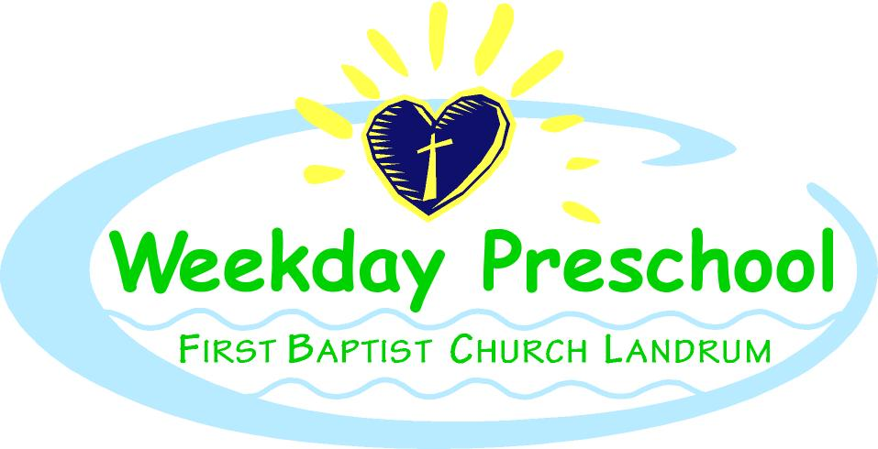
FBCL Weekday Preschool Registration 2021-2022
*Below is a list of our class offerings for the 2021-2022 school year. The child's birthday must be before September 1st. Please complete the registration form, front and back, and return it with the registration fee, as well as a copy of the child’s birth certificate. A spot can only be held if there is a completed form with the registration fee, class sizes are limited! On the form, indicate your choice from below.
1-year old class: choice of 2 days (T, TH) 3 days (M, W, F) or 5 days -- indicate on form
*our one-year-old class hours will be from 8:30-11:30 until Christmas and then 8:30-12:00 after Christmas. This allows for a time of transition to away-from-home care and to mornings without naptime. Tuition does not change.
2-year old class: choice of 2 days (M, W), 3 days (M, W, F), or 5 days -- indicate on form
3-year old class: choice of 3 days (M, W, F) or 5 days – indicate on form *must be potty-trained*
4-year old class: 5 day option only (This helps with the transition to "big school")
*Registration Fees: Non-refundable, $150 New Students/ $120 Returning Students
Tuition:
5 days: $225/month
4 days: $215/month *4 days is only an option in the 1’s, 2’s and 3’s classes for special circumstances, such as work schedules
3 days: $200/month
2 days: $185/month
Siblings: 1st child is regular price, 2nd child is reduced if attending same number of days.
Example: child #1: 5 days= $225; child #2: 5 days= $205(approx. 10%); child #3: 5 days: $200(10% + $5)
Special Service Fees:
Early Room: extra $25/month {If there is a need to be dropped off between 8:00 and 8:20} This is not available to the children in the 1 year old classes. It is available for children in the 3 year old and 4 year old classes the full year, and after Christmas to the children in the 2 year old classes, unless arrangements have been made with Mrs. Paula.
Bus to OPE(K4): We are able to provide transportation OP Earle K4. Depending on the number of children that need this service, will determine the price per child. We will take the average and divide it among the number of children using the bus. This is only for children that attend K4 here in the morning and OP Earle in the afternoon.

